It's not rocket science: Internet and the web

1. Introduction

Before you start programming websites, we'll show you how the internet works (it can be useful, right?).

2. History and context

The Internet as we know it today was invented in 1991 by a certain Tim Berners-Lee. This guy is at the origin of the third industrial revolution.

3. The resource

3.1. The web
Here are some videos to help you better understand how the internet works:
- To start, watch this video from BlueHost on the basic working principles of a website
- Then continue with this video from Remi Explique, which gives a good overview of websites using the well-chosen metaphor of postal mail
- Finish with this video from Harvard's very own CS50 explaining the HTTP protocol.
When you are done, we suggest you to follow the first chapters of Mathieu Nebra's excellent course: Understanding the Web :
- Introduction
- Define the web
- Distinguish the web from the internet
- Trace the history of the web
- To sum up

3.2. The client, the server

You may have seen these expressions: what is the client, what is the server?
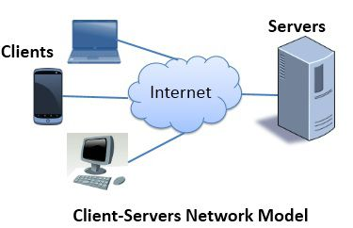
When your computer goes to a website, it will make a request to the website's servers. For example, when you go to google.com, you will send a request to Google's servers. The latter will check whether the request is correct. There are two cases:
- The request is correct: the servers will send you a response. This response is usually an html file that the client* (the browser of the person using the website) will interpret
- The request is incorrect: the servers will return an error message. Here are several examples of invalid requests:
  - 404 error: the page does not exist. Example with this page: google.com/lkdjf which returns this type of error.
  - Error 500: restricted access. You do not have access to this page. Example: a photo on Facebook that you do not have permission to see

* What we call "The Client" refers to any tool that makes a request to the server. This could be Safari on iPhone X, Chrome on your computer, or Google's little bots that index the entire web for their search engine. The metaphor is pretty good: the client makes a request, and the server serves it, like in a restaurant!

4. To go further
You can read the famous paper written by Tim Berners-Lee for the HyperText project.

And for fun, you can watch the episode of C'est Pas Sorcier devoted to the Internet. There is even one on the subject dating from 1998. Back to the past guaranteed!

